5D4N HANOI – HALONG – TAM COC/TRANGAN

DAY 1: HANOI – ARRIVAL ( D )
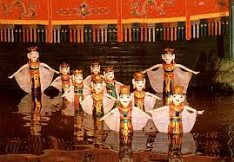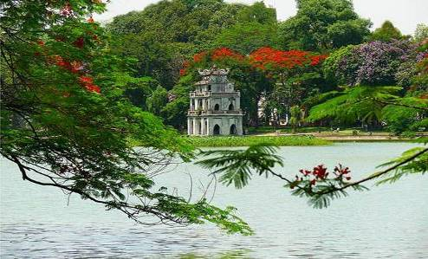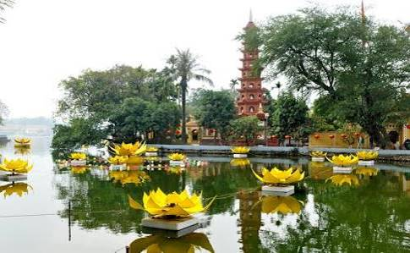
Water Puppet Show Hoan Kiem Lake Tran Quoc Temple
Upon arrival at Noi Bai International airport, our representative will meet and transfer to Hanoi downtown to visit the West Lake with Tran Quoc Pagoda, Hoan Kiem Lake ( Restored Sword Lake ) and shopping at 36 Old Quarter, enjoy Vietnam famous Water Puppet Show.

Meals: 1 Dinner
Accommodation: Overnight in Hanoi.
The distance: Noi Bai Airport – Hanoi Capital: 35km – 45 minutes for transfer.

DAY 2: HANOI – HALONG (B/L/D)
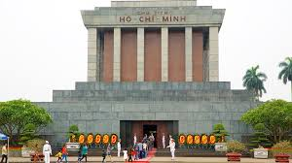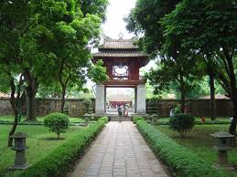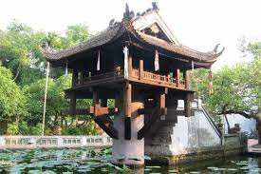
Ho Chi Minh Mausoleum Temple Of Literature One Pillar Pagoda
Breakfast at hotel, Transfer to visit Ho Chi Minh Mausoleum, Ho Chi Minh Palace, Ba Dinh Square, Uncle Ho' Stilt House, One Pillar Pagoda, continues to visit Temple of Literature. After lunch, transfer to Halong Bay - UNESCO World Heritage site (160km driving one way - 3.5hrs drive). This will be your first opportunity to see some of the rural areas of Vietnam. The drive goes through the Red River delta, so we'll have plenty of chance for taking photo of Vietnamese farmers tilling the vast green paddy field.

Meals: 1 Breakfast + 1 Lunch + 1 Dinner
Accommodation: Overnight in Halong
The distance: Hanoi – Halong Bay: 160km – 4 hours for transfer & break time on the way.

DAY 3: HALONG (B/L/D)
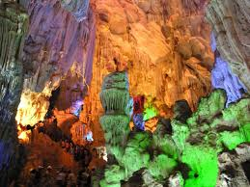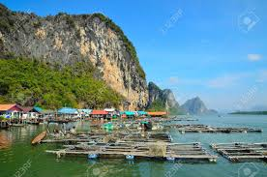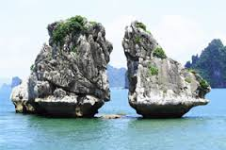
Paradise Grotto Fisherman Village Kissing Chicken Rock
After breakfast, transfer to Halong boat station to take our private boat to visit the world Heritage Halong Bay about 4 hours, our boat will bring us to visit Paradise Grotto, Kissing Chicken Rock, Fisherman Village, lunch will be served with fresh Halong Seafood, enjoy Vietnam Coffee on Cruise. In the afternoon, visit Hoang Gia Casino,

Meals: 1 Breakfast + 1 Lunch + 1 Dinner
Accommodation: Overnight in Halong

DAY 4: HALONG - TAM COC/TRANGAN – HANOI ( B/L/D)
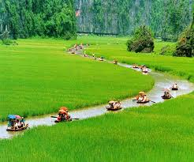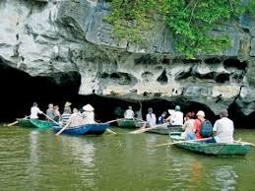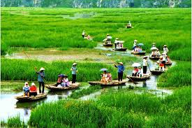
Tamcoc River
Options 1 : After breakfast, transfer to NinhBinh province, take sampan trip along the stream to visit Tamcoc River, Have a sightseeing the peaceful countryside of Vietnam. Discovering dry Halong bay Vietnam with rowing boat a long the streams and through many caves and visiting one of ancient citadel in Vietnam. lunch at local restaurant, transfer back to Hanoi, dinner at local restaurant, overnight in Hanoi.

Options 2 : After breakfast, transfer to NinhBinh province, take sampan trip along the stream to visit to Trang An - The Tourism Complex in the northern province of Ninh Binh was officially included in the world heritage list on June 23 by the UNESCO’s World Heritage Committee. The eco tourist attraction located in the East of Ninh Binh, with area of 2000 ha, It includes 47 historical vestiges with many mysterious things, with limestone mountains, valleys and underground river systems. Take boat trip to visit cave complex: Sang Cave, Toi Cave, Ba Giot Cave, Nau Ruou in mystery and wildness, see scenery of mountain and rivers Ha Long on land of Ninh Binh. The end of the day, drive back Hanoi. dinner at local restaurant, overnight in Hanoi.

Meals: 1 Breakfast + 1 Lunch + 1 Dinner
Accommodation: Overnight in Hanoi
The distance: Hanoi – Ninh Binh: 160km – 4 hours for transfer & break time on the way.

DAY 5: HANOI DEPARTURE (B)
Breakfast at hotel, free at leisure then transfer to airport for flight home.

Meals: 1 Breakfast
The distance: Hanoi Capital - Noi Bai Airport : 35km – 45 minutes for transfer.
The ends of program!

SEQUENCE OF ITINERARY SUBJECT TO LOCAL ARRANGEMENT

PRICE INCLUDE:
- Accommodation – as hotel in the list or similar – based on Twin/Double/Triple sharing
- Tour guide: English or Chinese speaking guide during the tour.
- Daily ABF and meals as mentioned in the program
- Shows and sightseeing in schedule.
- Transportation by private air-conditioner.
01 bottle ( 500 ml )of drinking water for each pax per day.
- Meals (Vietnamese Food & Chinese Food) as the tour code (B: Breakfast, L: Lunch, D: Dinner) 8-10 USD/meal/pax + one buffet at Sen Tay Ho Restaurant
- Free coke/beer/coffee/water on Halong Cruise.
- Boat fees private one in Halong and TamCoc/Trangan as mentioned in the program
PRICE EXCLUDE:
- International / Domestic flight ticket & airport tax (if have)
- Personal expenses: Tel, Fax, Mini Bar, Laundry,etc.
- Personal travel insurance
- Compulsory Tip for local guide and driver (USD/pax/day)

Group Size | Tips in USD
2 – 4pax | 6
5-7pax | 5
8 - up | 3

- Surcharge with other languages guide.
- Additional Meal will be surcharge 10usd/pax/meal.
- Surcharge at hotel case by case
  - Chinese New Year (TBA)
  - Gala Dinner on X’Mas (24, 25 Dec ) & New Year 31 Dec

Hotel listed or Similar |  | All rates are next in USD/PAX  valid Jan - Dec, 2020
 |  | Tour by private car / bus with private guide
HANOI | HALONG | 2 | 3-4 | 5-6 | 7-9 | 10-12 | 13-15 | 15+1 | 20+1 | 25 +1 | 30+1 | Sgl up
Larosa 3*  Pomihoa 3*  First Eden 3*  Thang Long Espana 3*  Adamas 3*  Authentic 3* | Seastar 3*  Golden Bay Ha Long 3*  Sen Hotel 3* | 416 | 358 | 311 | 283 | 281 | 261 | 258 | 251 | 243 | 241 | 91
Thang Long Opera 4*  Chalcedony 4  Hotel Kuretakeso 4*  Lan Vien 4* | Galaxy Ha Long 4*  Muong Thanh 4*  Au Lac 4*  Mithrin 4*  Song Loc 4* | 451 | 393 | 346 | 326 | 316 | 293 | 291 | 281 | 273 | 271 | 125

NOTE

The timing of sightseeing points shall be fixing by local operator due to traffic and weather conditions, however all points must cover unless amendment or cancellation make by clients themselves (Non-refundable for any cancellation that made by clients)

Tour and price are subject to change without notice or incase of deduct number of pax in quoted group.

Small deviations in the tour program are sometimes necessary, depending on weather, road conditions, flight schedules and room availability.

Supplement charge for room rate in peak dates depends on the hotel category used. Compulsory gala dinner on X’mas, New Year’s Eve & Lunar New Year’s Eve to be advised upon booking. Prices for group of 15 persons up in 5 stars hotels sometime requires to re-quote bases on the hotel policy

01 FOC for tour leader based on twin sharing basis include breakfast (domestic air ticket is not applicable).

BUS

Group Size | Kind of Transportation
1-2 pax | 4 seater
3 pax | 7 seater
4-9pax | 16 seater
10-18 pax | 30 seater
19-21 pax | 35 seater
22 – 42 pax | 45 seater

OPTIONIAL INFO:

1/ Trishaw to visit 36 old quarters 10 USD/1 pax/ 1 trishaw
2/ Vietnamese traditional massage in Halong bay: 1h30 minutes including tips: 20 USD/ pax.

- Commisstion 10% for tour leader

SHOPPING INFO:

1/ Hanoi local products
2/ Halong duty free jewelry center

- Commision 5% for Tour Leader

Tour request without shopping and no options will be surcharge 10USD/pax

CHILD POLICY

- Infant below 2 years old sharing same room with parents is free of charge.
- Child below 12 yrs old sharing same room with 1 ADL is charged for 90%.
- Child below 12 yrs old with extra bed and sharing same room with parents is charged for 65%.
- Child below 12 yrs old No extra bed & sharing same room with parents is charged for 55%

